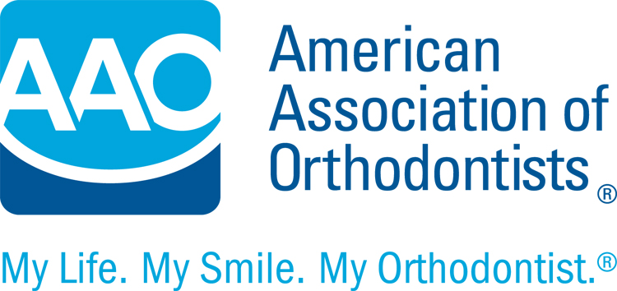
THIS IS A SUPPLEMENTAL INFORMED CONSENT

Informed Consent for Patient or Parent who Declines Progress Orthodontic Records
or Recommended Treatment for Themselves or a Child

I have declined my orthodontist's recommendation to have the following progress orthodontic records made or the following recommended treatment performed:

________________________________________________________________________________________________________________________________________________________________________________________________________________________________________________________________________________________________________________________________________________________________________
I realize that my refusal might compromise my (my child’s) orthodontic result in one or more of the following ways:
1. At the completion of orthodontic treatment, my (my child’s) bite might not be corrected (the fit
between the upper and lower teeth) and my (my child’s) teeth might not be as straight as they could
be.
2. My (my child’s) teeth might be more prone to return to their former positions after orthodontic
treatment is completed.

3. If the bite is not corrected, the teeth might be more prone to wearing and/or chipping.
4. My orthodontist will be unable to see problems in my (my child’s) teeth and jaws, such as root
shortening, uneven jaw growth, cysts, tumors, gum disease or impacted teeth.

These problems could lead to tooth loss or severe problems with the gums or bones.

Additional Comments:__________________________________________________________________________________________________________________________________________________________________________________________________________________________________________________________________________________________________________________________________________________________________________________________________________________________________________________________________________________________________________________________________________________

I agree to hold my orthodontist blameless for any consequences that might arise from my refusal to have orthodontic records made or treatment recommendations declined.

Patient/Parent_________________________________________Date:_______________

Orthodontist___________________________________________Date:_______________

